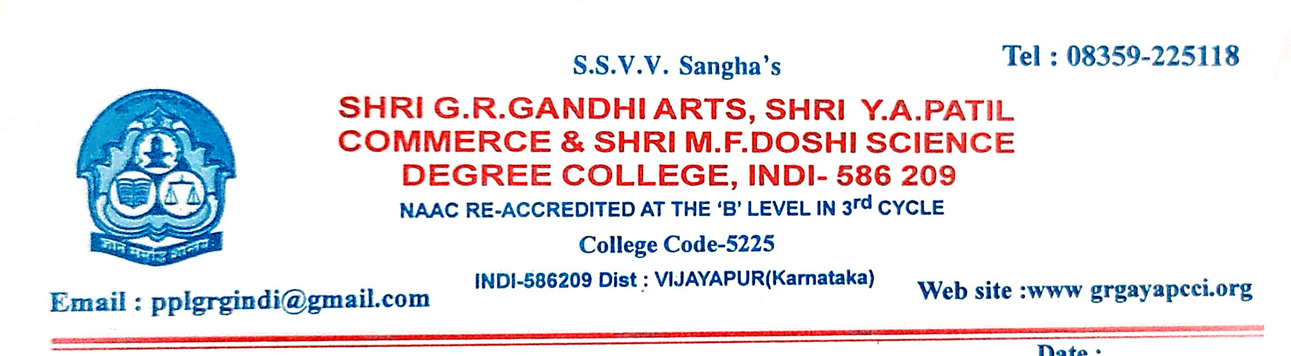
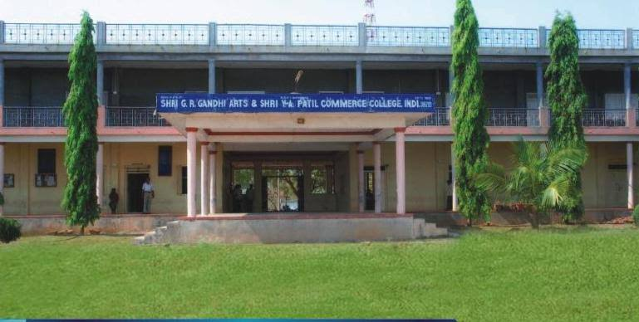

CRITERION VII - INSTITUTIONAL VALUES AND BEST PRACTICES

7.1.11 - Institution celebrates / organizes national and international commemorative days, events and festivals

7.1.11 - Institution celebrates / organizes national and international commemorative days, events and festivals
ANNUAL REPORT OF THE CELEBRATIONS AND COMMEMORATIVE EVENTS 2021-22

SI.NO | EVENT NAME | DATE | GUEST OF THE EVENT | NO.OF STUDENTS
01 | National Service Scheme Day | 24.09.2021 | Dr.Ramesh Kamble | 55
02 | Constitution day | 26.11.2021 | Prof.B.S.Patted | 95
03 | Subas Chandra Bose Jayanti | 24.01.2022 | Shri.Y.G.Biradar | 115
04 | Republic Day | 26.01.2022 | Shri.P.S.Bagali | 200
05 | D.R.Bendre Jayanti | 31.01.2022 | Shri.S.S.Irankeri | 70
06 | International Women’s Day | 08.03.2022 | Kumari.S.K.Bhagyashri | 85
07 | Environment Day | 06.06.2022 | Shri.S.B.Jadav | 50
08 | Yoga Day | 21.06.2022 | Shri.B.S.Patil | 70
09 | Independence Day | 15.08.2022 | Shri.P.S.Bagali | 115
10 | Rastriya Ekata Divas | 31.10.2022 | Dr.Jayprasad D | 62
11 | Kanakdas Jayanti | 11.11.2022 | Shri.Shrishail.G.Sannakki | 80
12 | Constitution Day | 26.11.2022 | Shri.Ishwar.S.M | 90
13 | Aids Day | 02.12.2022 | Shri.S.M.Ishwar | 55
14 | National Maths Day | 22.12.2022 | Shri.Dattatrey Hadpad | 55
15 | Savitribai pule Jayanti | 03.01.2022 | Mrs.Suma.Patil | 50
16 | Onake obavva Jayanti | 11.11.2021 | Dr. Jayaprasad D | 62
17 | National Science day | 28.02.2022 | Dr. Girija. Nimbal | 150
18 | Leagal awareness day | 26.11.2022 | Shri.Ishwar S M | 45
